Press Release

GRANDKEMANG HOTEL JAKARTA TO HOST INDONESIAN CONTEMPORARY ART & DESIGN (ICAD) 2018
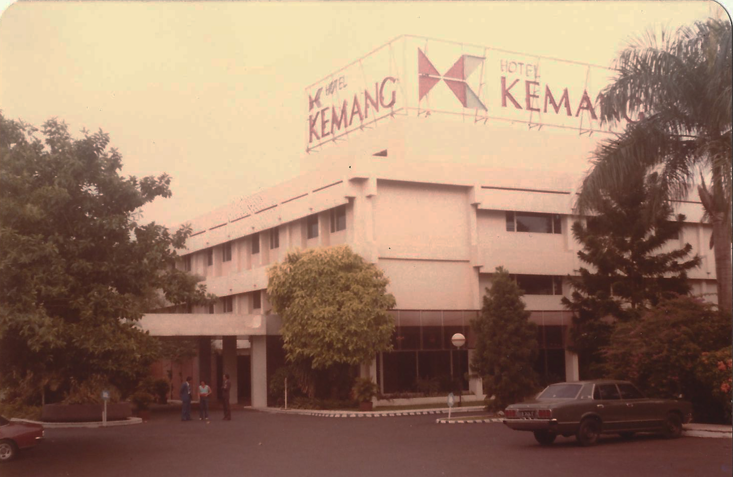
Jakarta, October – Indonesian Contemporary Art & Design (ICAD) is now back this year with a new theme ‘KISAH’ or ‘STORY, located at grandkemang Jakarta. This art exhibition will be open for public for 6 weeks until 30th of November 2018.

grandkemang Hotel Jakarta is proud to host ICAD once again since 2009, which marks this the 9th year to be the official venue of ICAD. The hotel is seen as a hip and trendy place which always has been a hangout spot for not only artists but also fashion designers and the international jet set, as it is located at the heart of South Jakarta. Thus, grandkemang Jakarta is a suitable and perfect place to host ICAD.

This year, ICAD is supported by Badan Ekonomi Kreatif Indonesia (Bekraf), Artura Insanindo, Yayasan Design + Art Indonesia and grandkemang Jakarta. ICAD is back on collaborating with creative artists from various of background and disciplines. There are 50 art installations, which include Irawan Karseno (artist), Ruby Roesly (architect), Tatang Ramadhan (graphic designer), Joshua Simanjuntak (furniter designer), White Shoes and The Couples Company (musicians), Milisifilem Collective (filmmaker), PM Toh (poet), Hikmat Darmawan (comic artist), and many more. The main curators from in ICAD 2018 are Hafiz Rencajale and Harry Purwanto. Other than the arts mentioned, this year ICAD also are displaying designers from Belgium, Joris Vanbriel and Vanessa Yuan (ecoBirdy). ecoBirdy’s works are always utilizing recycled materials, and always have ideas to contribute to the environment and education.

This year’s theme ‘KISAH’ alone is a story-telling for grandkemang as well, as the hotel has been established since 24th of April, 1974, called “Hotel Kemang”. It was firstly acknowledged one of the most popular accomondations by tourists, especially for the businessmen who travelled to Jakarta. During that time, that suburban area was infamous by its trees and was covered with tropical plants which were called “Kemang”. Until now, Kemang is still the main destination for business and recreation.

In 1995, Hotel Kemang did the first renovation. The hotel was upgraded to 205 rooms with more facilities to meet customer expectations. After years of operation, in 2004 the hotel entered the most exciting period of transformation. The hotel was upgraded and changed its name to “grandkemang Hotel Jakarta”.

Bring your friends and family to grandkemang Hotel Jakarta to enjoy the art exhibition and maximize your experience by taking pictures and share it on your social media.

For more information, please contact grandkemang Hotel Jakarta,
Jalan Kemang Raya no. 2H, Jakarta 12730,
Tel +62217194121 or email: info@grandkemang.com
Visit us www.grandkemang.com
***
grandkemang Jakarta is a contemporary hotel and the preferred residence in Kemang, the heart of urban living in South Jakarta. Conveniently and strategically located in the hub of great shopping, dining and entertaining venues, the hotel is just minutes from Jakarta’s main business district. The hotel offers 203 guest rooms and residence suites for both travellers and long stay guests, complete with newly renovated luxurious facilities, featuring International standards of comfort and convenience.

- End –

For more information:
Yuanita Ayu Pratama
Marketing Communication Manager
grandkemang Jakarta 3rd Floor
Jl. Kemang Raya 2H, Kebayoran Baru, Jakarta 12730
Phone : +62 21 719 4121 ext 716
Email : mm@grandkemang.com
Website : www.grandkemang.com
Facebook, Twitter & Instagram: @grandkemangJKT

Marissa Ariesta Sastradiredja
Marketing Communication Officer
grandkemang Jakarta 3rd Floor
Jl. Kemang Raya 2H, Kebayoran Baru, Jakarta 12730
Phone : +62 21 719 4121 ext 719
Email : pr@grandkemang.com
Website : www.grandkemang.com
Facebook, Twitter & Instagram: @grandkemangJKT

