PRESS RELEASE
For Immediate Release
CELEBRATING DELIGHTFUL FESTIVE SEASON AT GRANDKEMANG JAKARTA
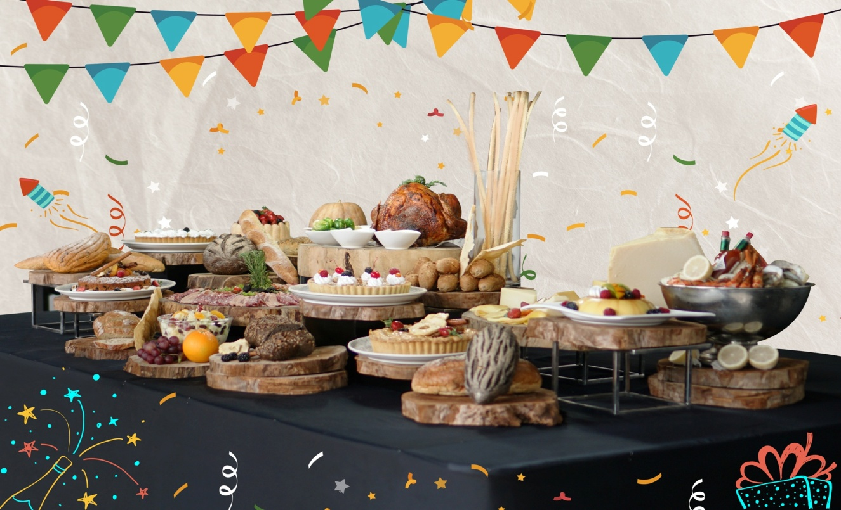
Jakarta, November 2018 – Make Christmas and New Years Eve delightful with family and friends, by celebrating at grandkemang Hotel Jakarta. Colorful decorations will be set off throughout the hotel to lighten the festive season. Our packages offering will make you end 2018 lively as you welcome 2019.
FESTIVE SEASON
Christmas Day Brunch
December 25, 2018 | 12 – 3 pm | Sperta Restaurant
The Festive Season culinary journey starts on Christmas Day with an extensive brunch buffet for only IDR 325.000++/person. You may celebrate Christmas with family and friends in Sperta restaurant with the finest ingredients ranging from European specialties with a spread of Asian cuisine, Western Carving Station, Italian Pasta Corner, Dim Sum Station, Sushi & Sashimi Corner, Indonesian favorites, wide selections of the best French bread and cheese complemented with Parma Ham selections, roasted turkey, dessert and pastries, and beverages station. For those who will bring children, do not worry about your kids getting bored because we will be having fun activities for them too.
Christmas Room Packages
December 24 – 25, 2018
grandkemang Jakarta also offers a very special staycation with many attractive inclusions. Starting from IDR 1,500,000 nett, guest may enjoy a 1 (one) night stay in our rooms including welcome drinks, Christmas Brunch and breakfast for 2 persons at Sperta restaurant.
Christmas Treats & Hampers
This year’s Christmas is also the right time to send special gifts to family, friends and colleagues. D’Courtyard has prepared Christmas hampers for only IDR 550.000++ consisting of 8 cookie jars, which are Zimtsterne, Speculaas, Vanilla Kipferl, Ginger Cookies, Chocolate Sable, Ananastar, Kaastangel, Roasted Nuts, and one signature cake of grandkemang. Don’t miss our special Christmas cake and cookies offered too, which are the traditional Yule Log for IDR 300.000 nett, Christmas Pudding for IDR 250.000 nett, Ginger Bread House for IDR 250.000 nett and Christmas Fruit Cake for IDR 300.000 nett.
New Year’s Room Package
December 30 - 31, 2018
Let’s welcome a fresh beginning of 2019 together with grandkemang Hotel Jakarta with a special offer of one or two nights stay starting from IDR 2.100.000 nett/room, including Gala Buffet Dinner for 2 persons and breakfast for 2 persons at Sperta Restaurant.
Gala Buffet Dinner
December 31, 2018 | 7 – 10 pm | Sperta
Celebrate the last day of 2018 by having a dinner buffet with delectable varieties of International and Asian favorites such as lamb chops, selection of cheese including raclette, roast turkey and roasted rib eye, parma ham, dim sum, sushi, sashimi, selection of dessert and many more. Guests may enjoy the buffet spread for only IDR 325.000++/person, including free flow ice tea and juice. With additional of IDR 250,000++/person, guests can have free flow of wine and beer.
grandkemang Hotel Jakarta has all you need to spend the festivities that will certainly makes this Christmas and New Year more delightful.
For further information or reservation, please call grandkemang Jakarta or Sperta Restaurant at 0217194121 or email us at: resv@grandkemang.com
Visit us at www.grandkemang.com
Jalan Kemang Raya 2H, Kebayoran Baru, Jakarta Selatan.

grandkemang Jakarta is a contemporary hotel and the preferred residence in Kemang, the heart of urban living in South Jakarta. Conveniently and strategically located in the hub of great shopping, dining and entertaining venues, the hotel is just minutes from Jakarta’s main business district.
-End-

For more information:
Yuanita Ayu Pratama
grandkemang Jakarta 3rd Floor
Jl. Kemang Raya 2H, Kebayoran Baru, Jakarta 12730
Phone : +62 21 719 4121 ext 716
Email : mm@grandkemang.com
Website : www.grandkemang.com
Twitter & Instagram: @grandkemangJKT

Marissa Ariesta Sastradiredja
grandkemang Jakarta 3rd Floor
Jl. Kemang Raya 2H, Kebayoran Baru, Jakarta 12730
Phone : +62 21 719 4121 ext 719
Email : pr@grandkemang.com
Website : www.grandkemang.com
Twitter & Instagram: @grandkemangJKT

