PRESS RELEASE
For Immediate Release

CELEBRATION OF THANKSGIVING AT GRANDKEMANG JAKARTA
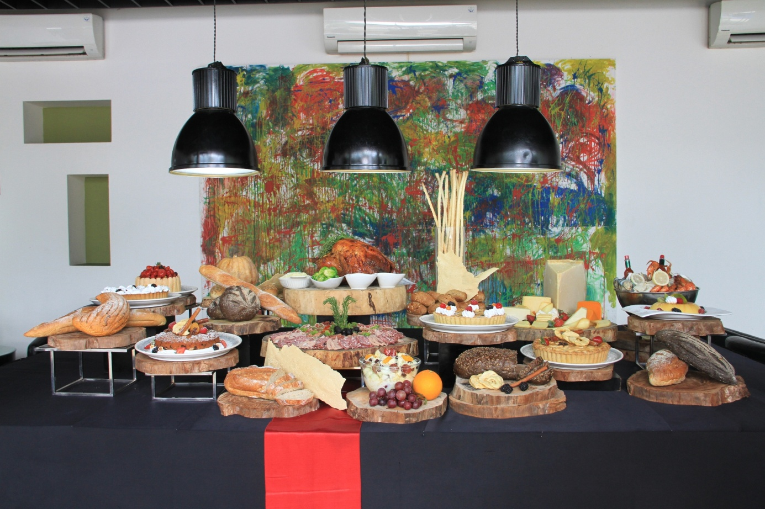
Jakarta, November 2018 – Celebrate the turkey festive of Thanksgiving at grandkemang Jakarta, because this year we have a different way to celebrate the festivity. Our packages offering will make your Thanksgiving to embrace the blessings along with your loved ones.
Thanksgiving Dinner Buffet
November 29, 2018 | Sperta
Start your Thanksgiving dinner feast with your family at grandkemang Jakarta of all-you-can-eat at Sperta Restaurant for only IDR 325.000++/person, on Thursday 29th of November 2018 from 7 p.m. to 10 p.m. Children of age 0 to 4 years old are free to enter and children from 5 to 12 years old will get a 50% discount off.
There are special dishes prepared by our chefs using the finest ingredients ranging from European specialties with a spread of Asian cuisine, Italian Pasta Corner, Sushi & Sashimi Corner, wide selections of the best French bread and cheese complemented with Parma Ham selections, Pizza Corner, Seafood on Ice, desserts and pastries, free flow beverages and of course, favorite American BBQ & cuisines.
Only for IDR 450.000++/person, you may enjoy the free flow of Red Wine / White Wine / Sparkling Wine / beer.

grandkemang Jakarta has all the lavish dishes you need to spend on this special day that will certainly makes this Thanksgiving merrier.

For further information or reservation, please call grandkemang Jakarta – Sperta Restaurant at 0217194121 or email us at: fbm@grandkemang.com
Visit us at www.grandkemang.com
Jalan Kemang Raya 2H, Kebayoran Baru, Jakarta Selatan.

grandkemang Jakarta is a contemporary four star hotel and the preferred residence in Kemang, the heart of urban living in South Jakarta. Conveniently and strategically located in the hub of great shopping, dining and entertaining venues, the hotel is just minutes from Jakarta’s main business district.
-End-

For more information:
Yuanita Ayu Pratama
grandkemang Jakarta 3rd Floor
Jl. Kemang Raya 2H, Kebayoran Baru, Jakarta 12730
Phone : +62 21 719 4121 ext 716
Email : mm@grandkemang.com
Website : www.grandkemang.com
Twitter & Instagram: @grandkemangJKT

Marissa Ariesta Sastradiredja
grandkemang Jakarta 3rd Floor
Jl. Kemang Raya 2H, Kebayoran Baru, Jakarta 12730
Phone : +62 21 719 4121 ext 719
Email : pr@grandkemang.com
Website : www.grandkemang.com
Twitter & Instagram: @grandkemangJKT

