PRESS RELEASE
For Immediate Release
GOOD FORTUNE ABOUNDS AND LOVE IS IN THE AIR AT GRANDKEMANG JAKARTA
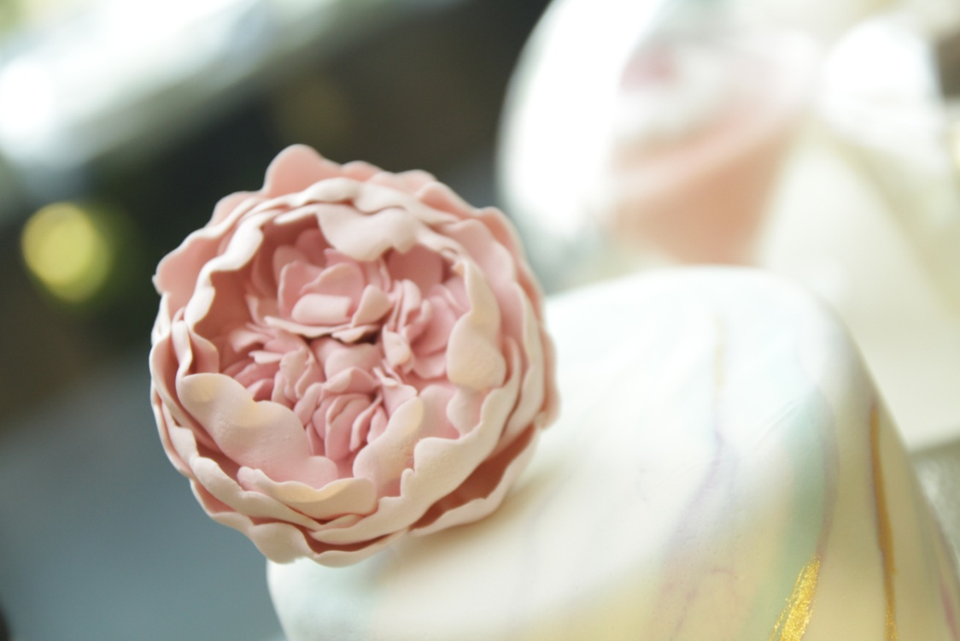

Jakarta, January 2018 – We have been enthusiastic entering the New Year 2018 with new goals and resolutions to accomplish. grandkemang Jakarta has arranged some prosperity offers for the upcoming Valentine’s day and Lunar New Year to start off the spirit and excitement of 2018 that marks as the Year of the Dog in the Chinese calendar.
The Amorous Valentine’s Dinner
February 14, 2018 | 7 p.m. – 10 p.m. | Sperta
Valentine’s Day comes only once in a year. grandkemang Jakarta offers you a package to win the heart of your loved one on Valentine’s Day. Take your partner to an amorous dinner at Sperta and be spoiled with a sumptuous 4-course set menu:
- Foie Gras and Chicken Liver Terrine for the starter,
- Lobster Bisque soup,
- Surf and Turf for the main course,
- The sweet Valentine’s Chocolate Dome for the dessert.
A pair of violinist and pianist will be there to entertain you while you are enjoying the delectable dinner specially made by our culinary expert. All those happiness can be reached for only IDR 550,000++/couple. Your significant other may get mesmerized by your love, but our meticulously-plated set menu and a hidden surprise will be the way to win their heart.

LUNAR NEW YEAR
Prosperous Stay Packages
February 16 - 18, 2018
It’s great that Chinese New Year 2018 falls on Friday, which means there will be a long weekend holiday. Bring the whole family and celebrate the Lunar Festive at grandkemang Jakarta with Prosperous Stay Packages:
- 2-night stay for only IDR 1,888,000 net per room includes breakfast buffet for 2 persons and a special dining voucher at Sperta worth IDR 200,000.
- 1 night stay for only IDR 888,000 net per room includes breakfast buffet for 2 persons.
Prosperity Brunch
February 18, 2018 | 12 p.m. – 3 p.m. | Sperta
Let the Lunar New Year celebrations continue with the Prosperity Brunch at Sperta, grandkemang Jakarta on Sunday, February 18, 2018. We will spoil your appetite with a vast selection of oriental favorites such as: Noodle Station, Dim Sum Corner, Carving Station of Peking Duck and Roasted Beef, Sushi & Sashimi Corner, Desserts Corner, and many more. Meanwhile, the cute little Barongsai will perform to cheer the festivities. All those packages can be enjoyed for only IDR 275,000++/person, and with only additional of IDR 250,000++/person, guests may enjoy free flow of red, white & sparkling wine and beer. Try your luck, get a fortune cookie, and stand a chance to win prizes.
Stroke of luck awaits you in this year of the Dog!
For reservation and information, please contact +6221 7194121 or email info@grandkemang.com
***
grandkemang Jakarta is a contemporary hotel and the preferred residence in Kemang, the heart of urban living in South Jakarta. Conveniently and strategically located in the hub of great shopping, dining and entertaining venues, the hotel is just minutes from Jakarta’s main business district. Equipped with 203 rooms, 14 meeting and function rooms, lounge, swimming pool, gym facility, kids’ playroom, and in-room spa. Moreover, our experienced caterers are experts in their kitchen and ready 24/7 to suit your banquet and catering needs. Best hotel to accommodate both your business and leisure activities.
-End-

For more information:
Dhea Minerva Hyaringga
Asst. Marketing Communication Manager
grandkemang Jakarta 3rd Floor
Jl. Kemang Raya 2H, Kebayoran Baru, Jakarta 12730
Phone : +62 21 719 4121 ext 711
Fax : +62 21 719 4131
Email : amm@grandkemang.com
Website : www.grandkemang.com
Facebook : grandkemang Hotel
Twitter & Instagram: @grandkemangJKT

