Press Release

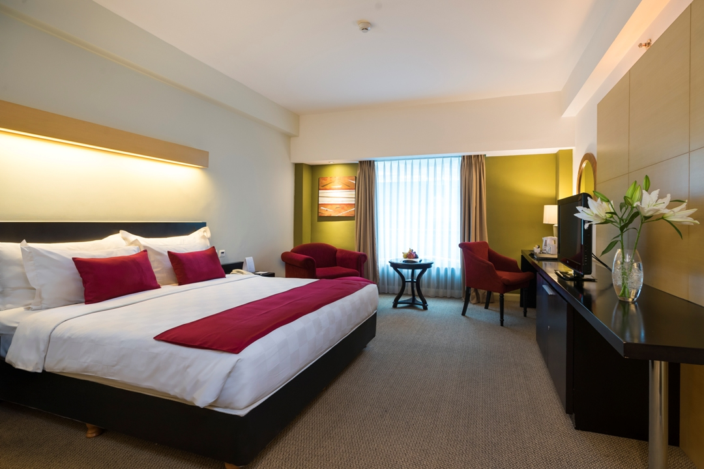
CELEBRATING 73rd ANNIVERSARY OF INDONESIA’S INDEPENDENCE DAY & IDUL ADHA WITH ATTRACTIVE PROMOTIONS WITH GRANDKEMANG JAKARTA
Jakarta, August 2018 – The 17th of August is the day where Indonesians are out to celebrate Independence Day! This year, the 17th falls on a Friday and Idul Adha falls on a Wednesday, which means it is going to be a long weeked and even longer if you are taking leave. Many people choose to go to several cities close to Jakarta as their holiday destination. Knowing the traffic would be bad as everyone will be going out of town, why not spending your long weekend in Jakarta? To enliven your celebration holiday, grandkemang Jakarta has prepared exclusive independence packages for you and your loved ones. Book a room from our website starting from IDR 890.000 nett in Deluxe room and IDR 990.000 nett in Grand Deluxe room. The packages include daily buffet breakfast for 2 guests in Sperta restaurant, free 2 pieces for laundry, free shuttle service to Lippo Mall Kemang, 20% off for food and beverages dine-in, 20% off for Spa and free late check out based on availability. This exclusive offer is valid from 15th until 26th of August 2018.

You can experience staying at grandkemang with complete facilities and ecstatic entertainment available in restaurant, lounge, swimming pool, fitness center, business center, and some art installations that will refresh your body and soul. You can also enjoy the free Wi-Fi in the hotel. You can enjoy Brunch It Up!, the regular Sunday Brunch buffet at Sperta restaurant for only IDR 325.000++/person incl. free flow of juices, ice lemon tea, coffee or tea, water. With only additional of IDR 250.000++/person on the brunch price, you may enjoy the free flow of Red Wine / White Wine / Sparkling Wine / beer. Brunch It Up! Is free for children who are 16 years old, up to 2 children per family.

For reservation and more information about this offer, please contact grandkemang Jakarta,
Jalan Kemang Raya no. 2H, Jakarta 12730,
Tel +62217194121 or email: resv@grandkemang.com
Visit us www.grandkemang.com
***
grandkemang Jakarta is a contemporary hotel and the preferred residence in Kemang, the heart of urban living in South Jakarta. Conveniently and strategically located in the hub of great shopping, dining and entertaining venues, the hotel is just minutes from Jakarta’s main business district. The hotel offers 203 guest rooms and residence suites for both travellers and long stay guests, complete with newly renovated luxurious facilities, featuring International standards of comfort and convenience.

- End –

For more information:
Yuanita Ayu Pratama
Marketing Communication Manager
grandkemang Jakarta 3rd Floor
Jl. Kemang Raya 2H, Kebayoran Baru, Jakarta 12730
Phone : +62 21 719 4121 ext 711
Email : mm@grandkemang.com
Website : www.grandkemang.com
Twitter & Instagram: @grandkemangJKT

Marissa Ariesta Sastradiredja
Marketing Communication Officer
grandkemang Jakarta 3rd Floor
Jl. Kemang Raya 2H, Kebayoran Baru, Jakarta 12730
Phone : +62 21 719 4121 ext 711
Email : pr@grandkemang.com
Website : www.grandkemang.com
Twitter & Instagram: @grandkemangJKT

